

A Project Report On

**Placement Management System**

**By**

**Esther JerlinBorchiya.V**

**Ishita Raja R J**

**Mohamed Suhailla**

**Suriya S**

**Raashitha Nihara**

**Batch:**2021-5622

**Center:Chennai**

Under the Guidance of,

**Jayanth .V**

**TechnicalTrainer**

**EduBridge**

(School of coding)

**Introduction:**

Our project explains about the Placement Management System.This project mainly explains the various actions related to apply to career online. You can apply for various Professions accordingly.Our Project Include **Modules:-**

* Admin Module
* User Module

I have developed this Application in **Java, JSP, Servlets, Hibernate and MySQL.** It’s a web-based projects so I have used **HTML, CSS,JavaScript and Bootstrap also**.

The main feature of the project is to make the search for career more easier. You can access this website from anywhere and everywhere.

In Admin module, admin can add the Students, Placement related information ,colleges ,Certificates and Users. He can also view the total number of Students, Colleges, Certificates, Users and Admin at present in the website. And Placement related information also.

In User module, user can access the website to add the student details, Placement details and the certificates that has been received. New user also has the access as like the already existing user. In

**Software Requirements:**

**Front end:** Java/J2EE technologies (Servlet, JSP), HTML, CSS, JavaScript, Bootstrap,Hibernate.

**Back-end**:MySQLworkbench8.0.23CE.

**Middleware/Server:** Apache Tomcat v9.0. IDE: Eclipse IDE for Java EE Developers

**Browser:** Best result on Google Chrome

**Operating System:**Window10.

# Data Dictionary:

* Create Database userdemo;
* Hibernate: create table Admin (Id integer not nullauto_increment,namevarchar(255),password varchar(255),primarykey(categoryId))engine=InnoDB
* Hibernate: create table Certificate (Id integer not null auto_increment,collegevarchar(3000), year integer not null, primary key (pId))engine=InnoDB
* Hibernate: create tableCollege (id integer not nullauto_increment, collegeadminvarchar(1500),collegenamevarchar(100),location(100), primarykey (user_id))engine=InnoDB.
* Hibernate: create tableCollege (id integer not nullauto_increment, collegeadminvarchar(1500),collegenamevarchar(100),location varchar (100), primarykey (user_id))engine=InnoDB.
* Hibernate: create table placement (id integer not nullauto_increment, college varchar(1500), date Date,namevarchar(100),qualification varchar(100), year integer primarykey (user_id))engine=InnoDB.
* Hibernate: create table Student (id integer not nullauto_increment, certificate varchar(1500), collegevarchar(100),course varchar(100), hallticketno integer, namevarchar(100), qualification varchar(100), primarykey (user_id))engine=InnoDB.
* Hibernate: create table User (id integer not nullauto_increment, namevarchar(1500),password namevarchar(100),type varchar (100), primarykey (user_id))engine=InnoDB.

# Screenshots:-

**Home Page:**

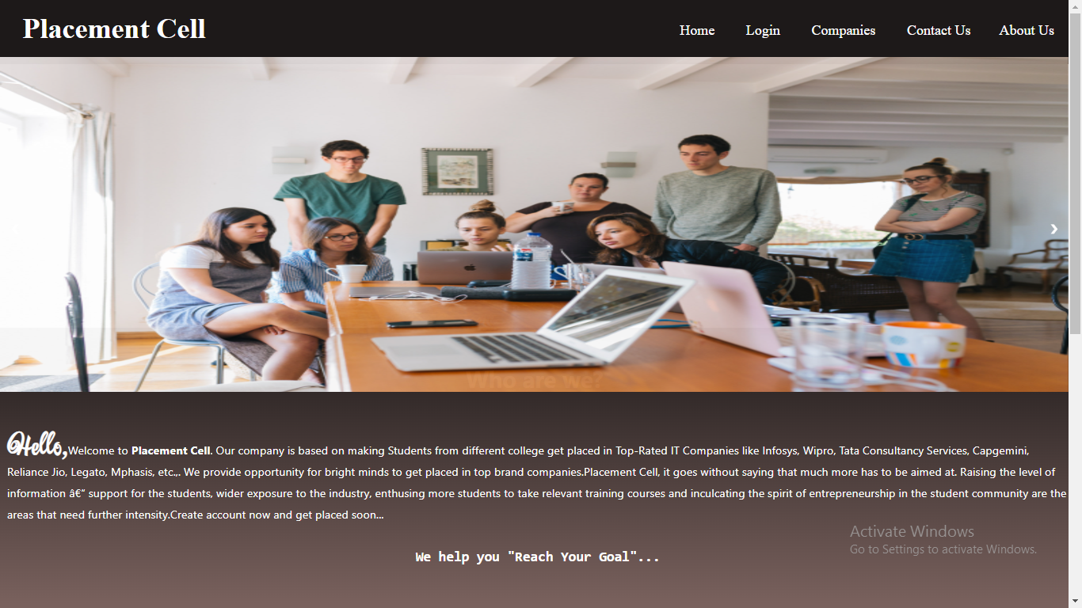

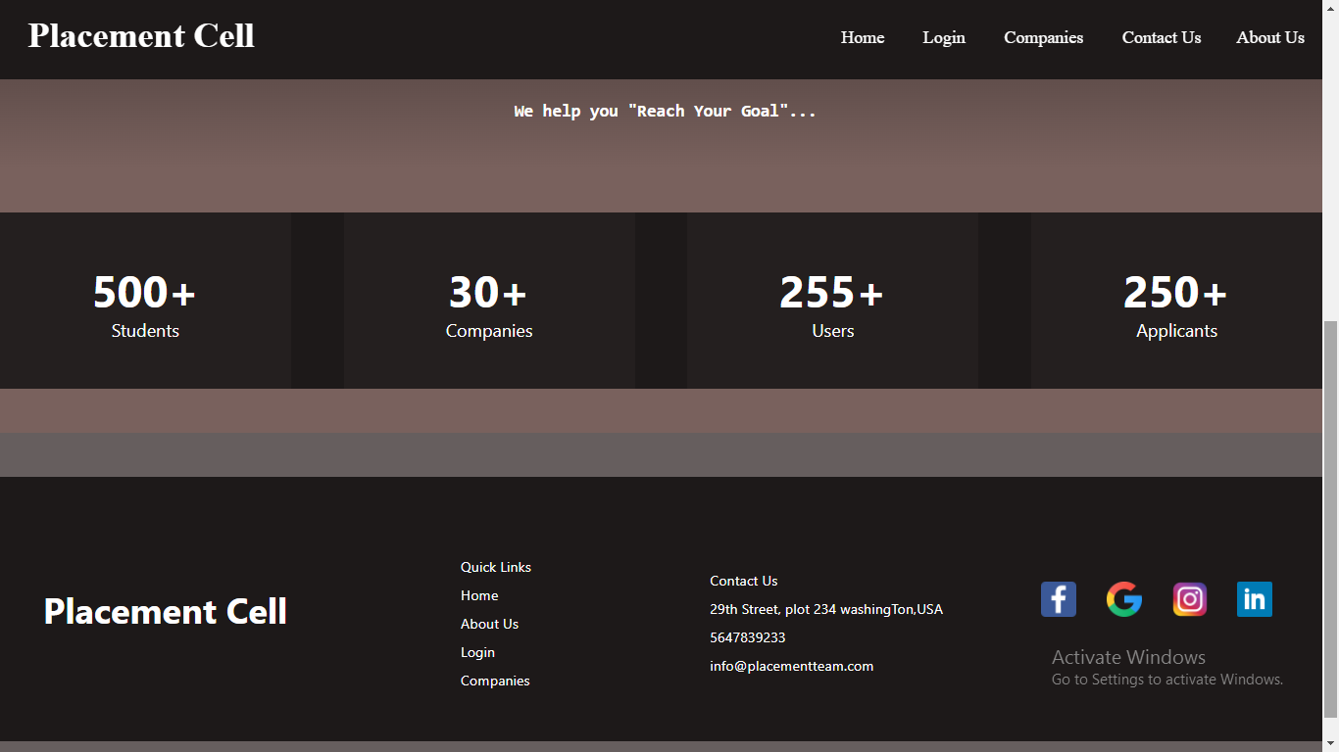

**Login Page:**

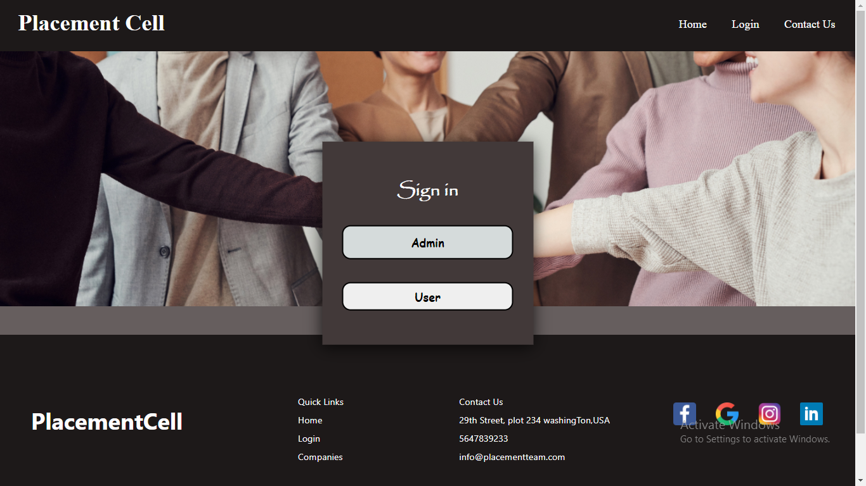

**Admin Login Page:**

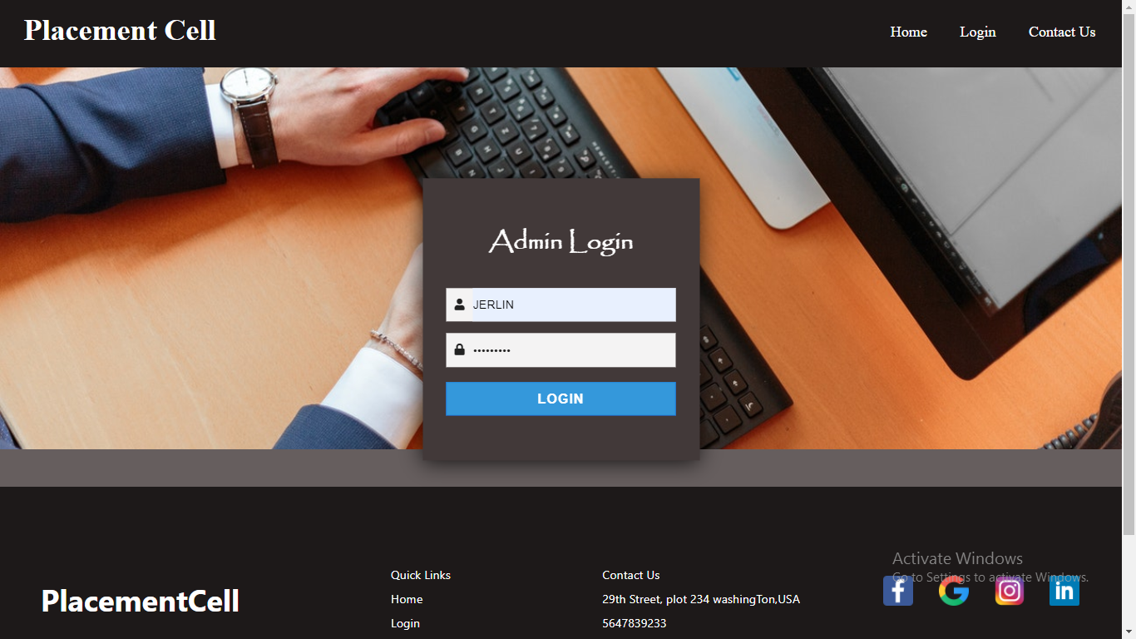

**Admin Dashboard Page:**

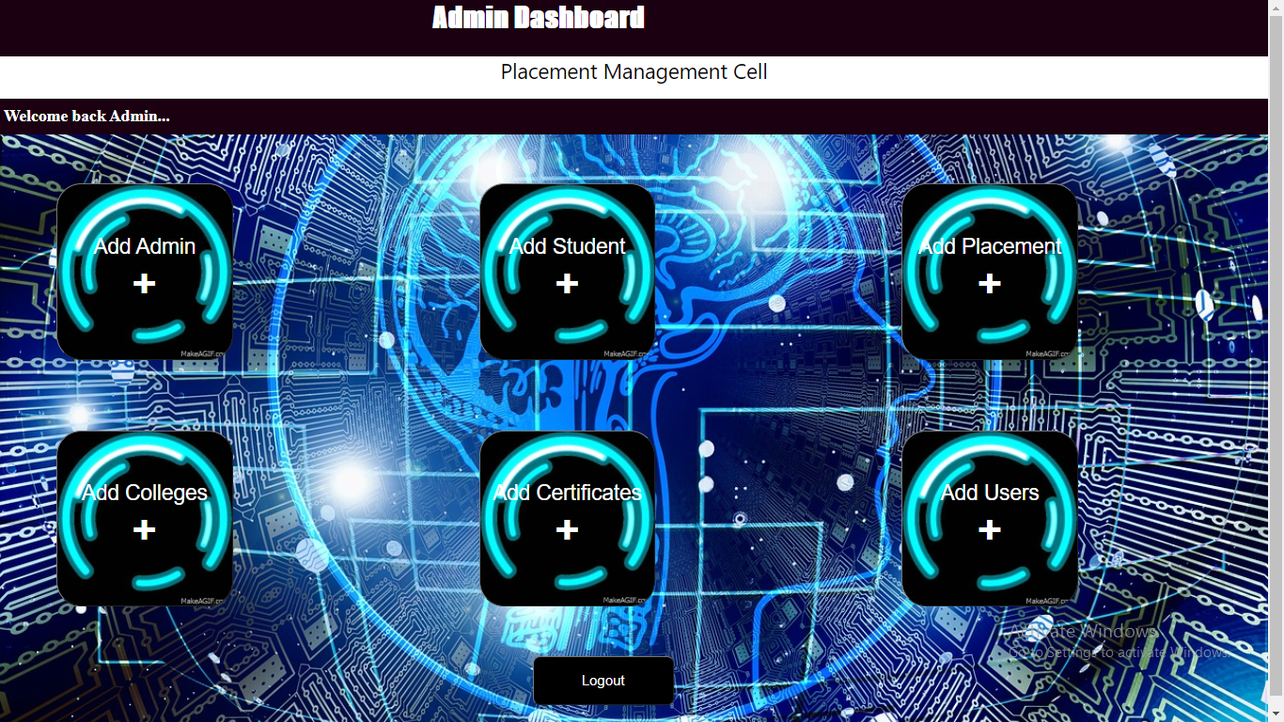

**Add Admin Page:**

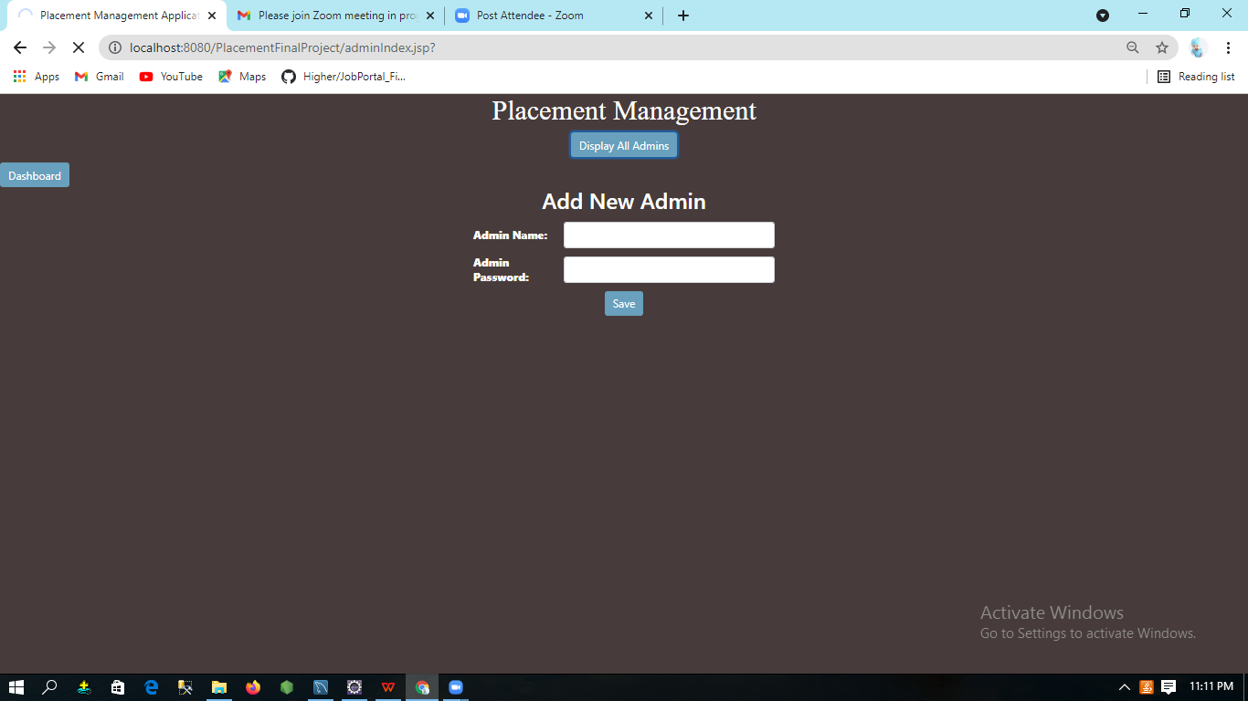

**Display Admins Page:**

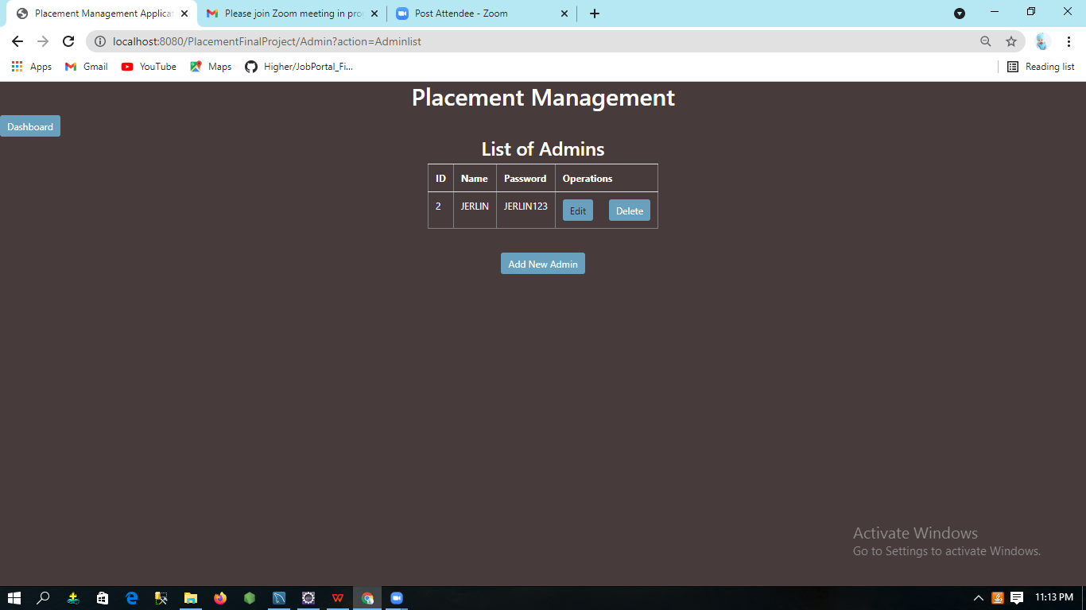

**Add Student:**

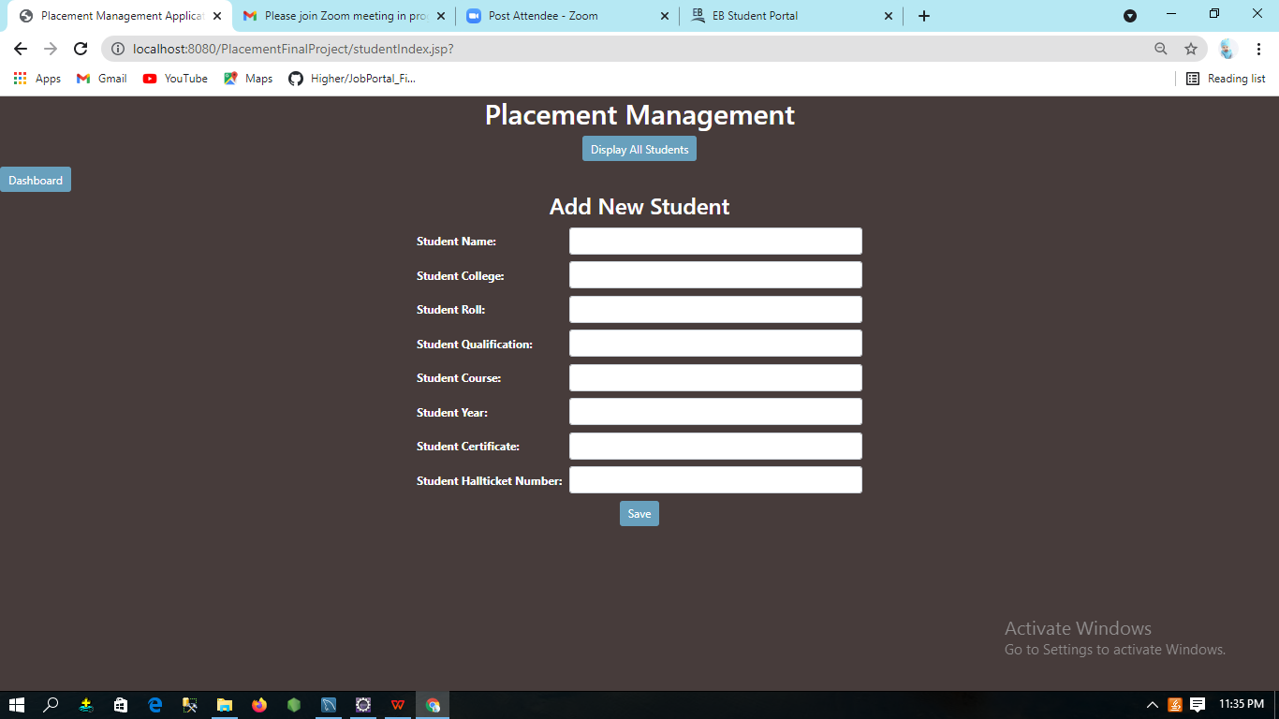

**Display Student Page:**

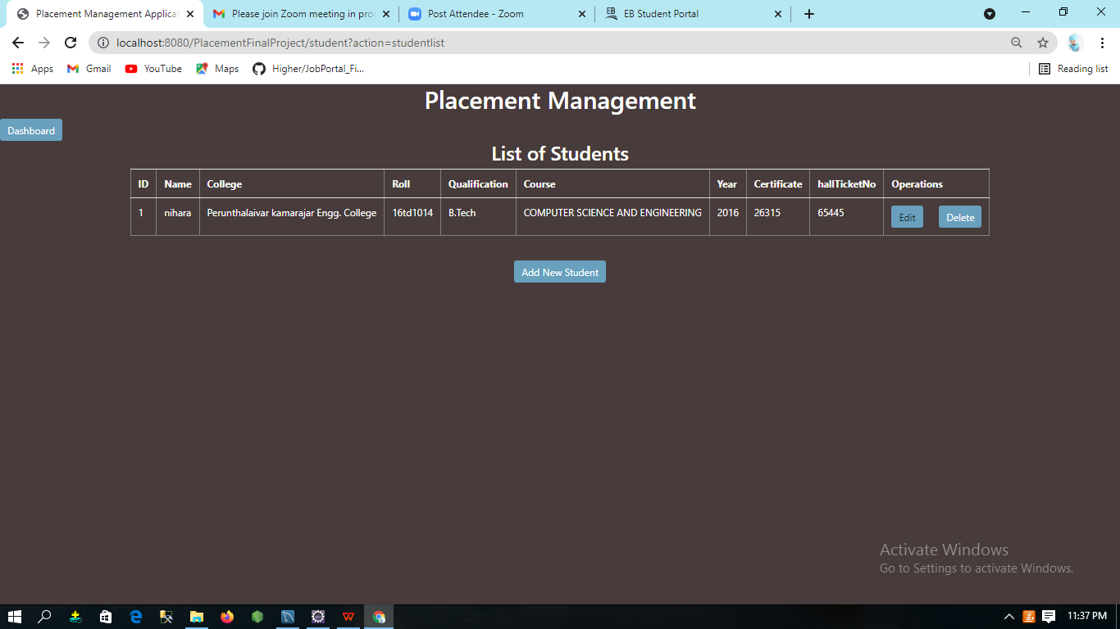

**Add Placement Information:**

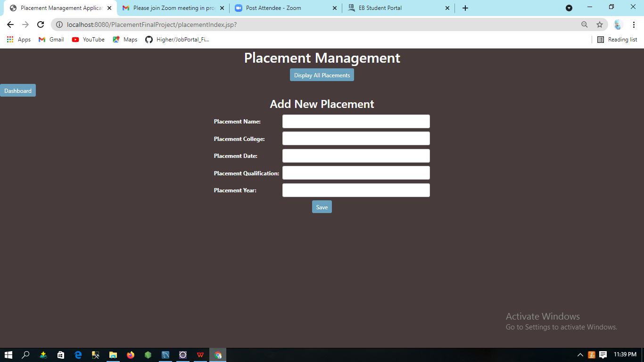

**Display Placement Information Page:**

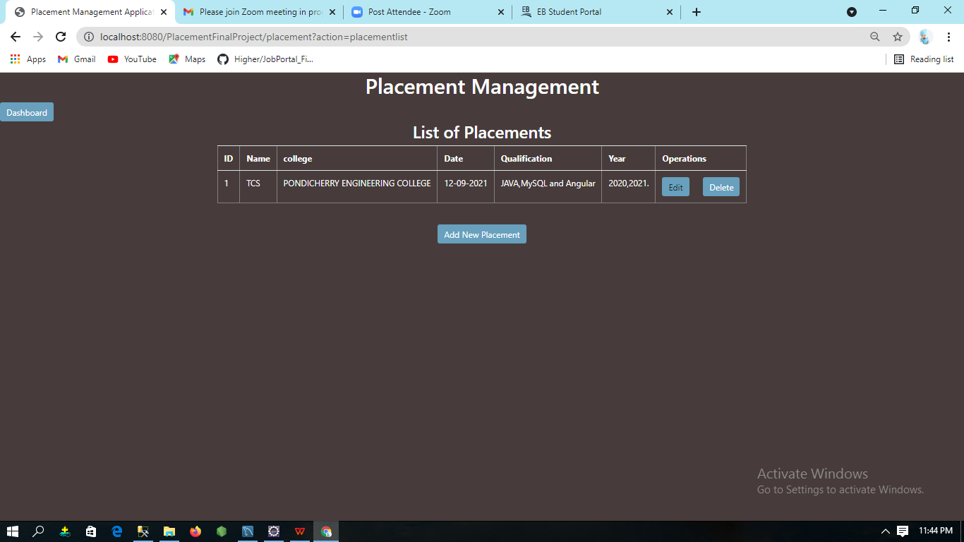

**Add College Page:**

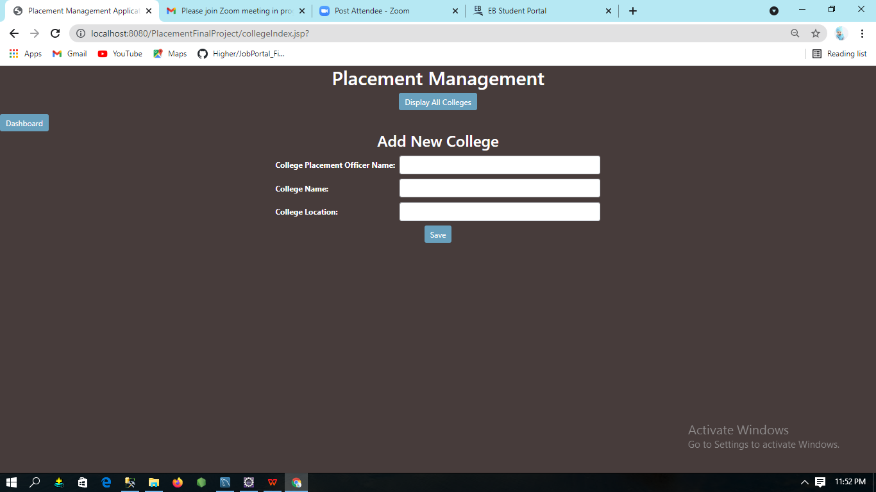

**Display College Page:**

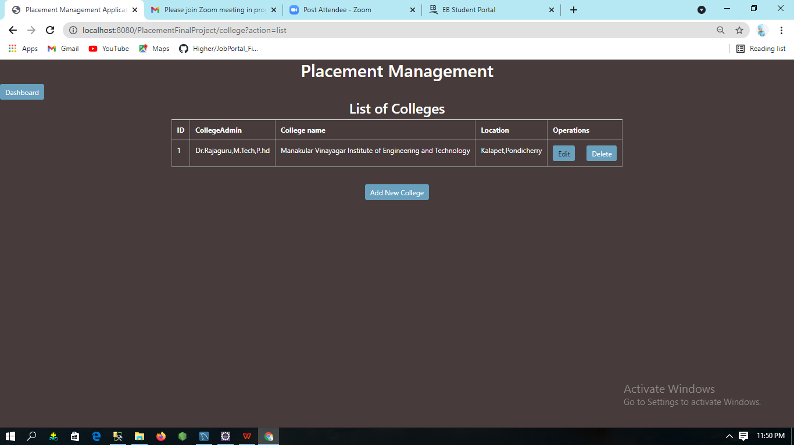

**Add Certificate:**

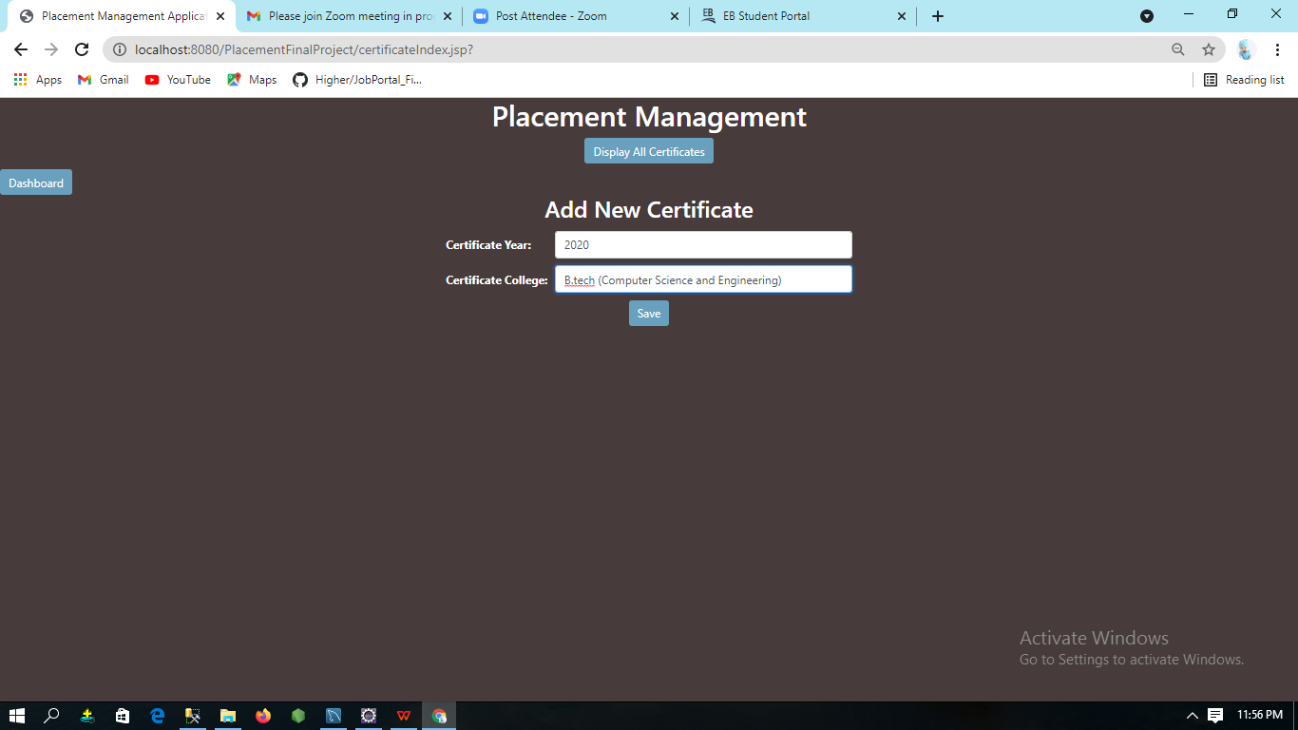

**Display Certificate Page:**

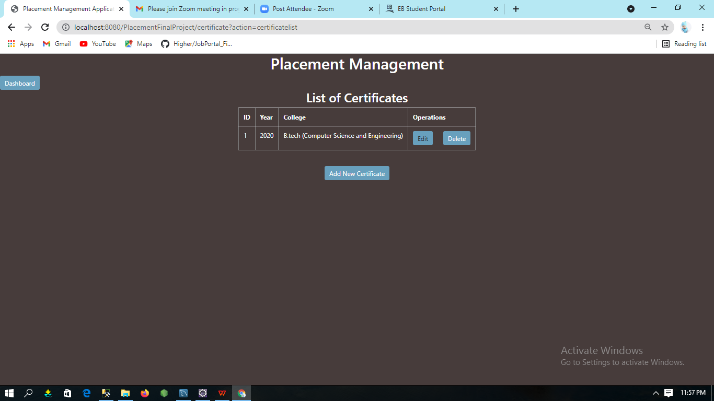

**Certificated Page To Perform Updation:**

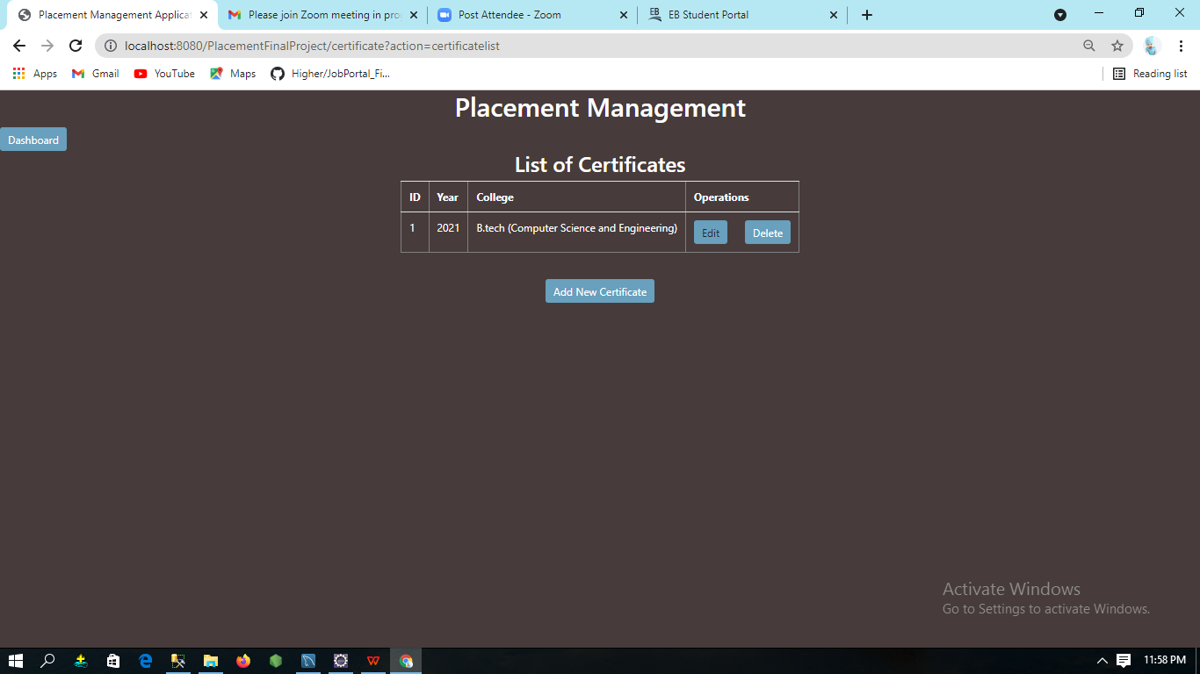

**Add User:**

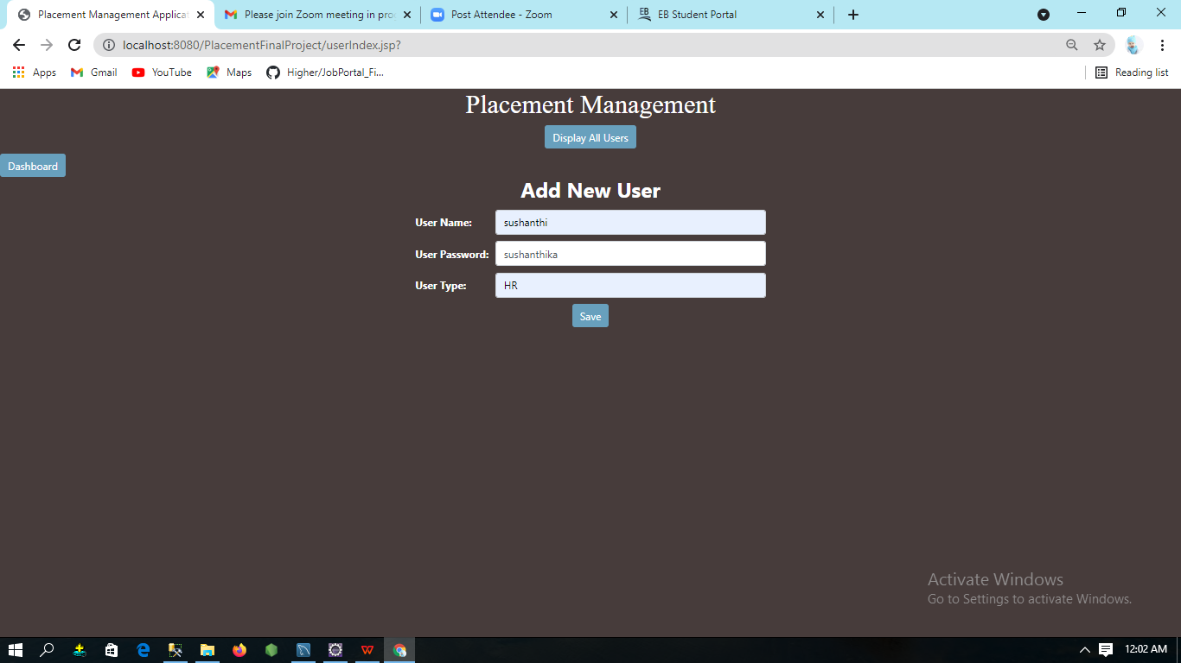

**Display User Page:**

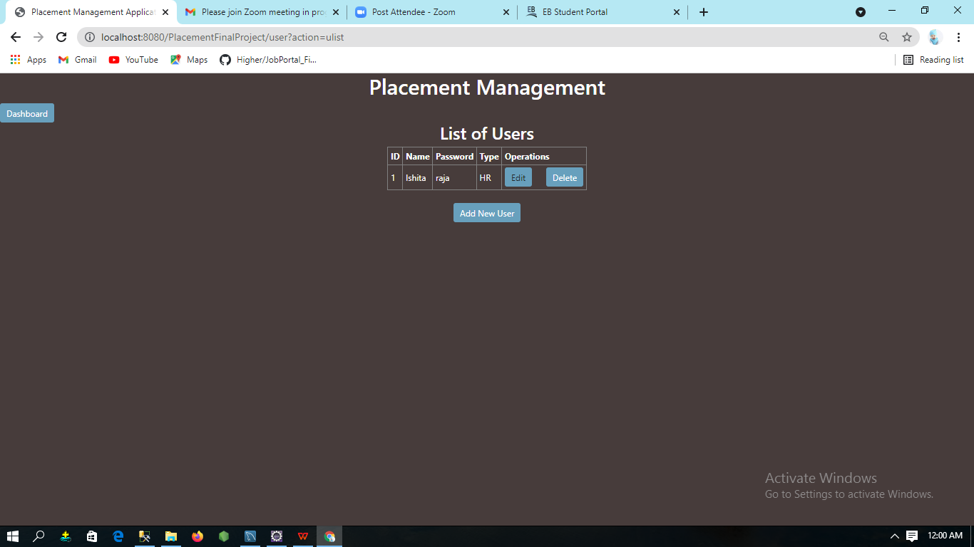

**User Login Page:**

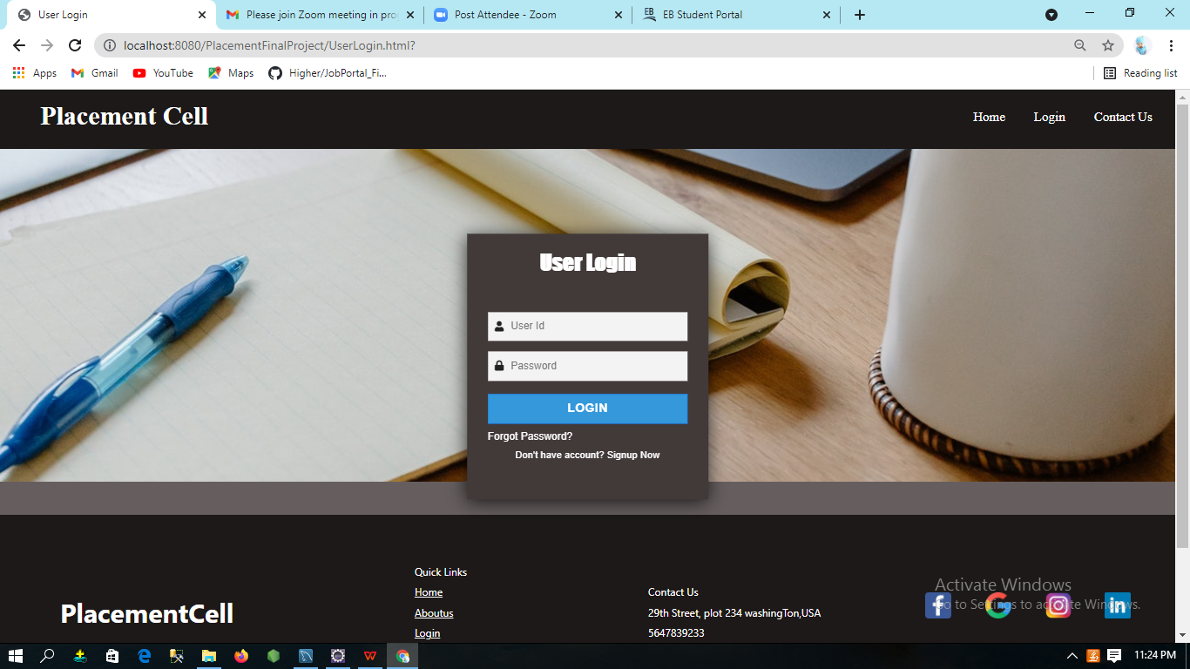

**Registration for User:**

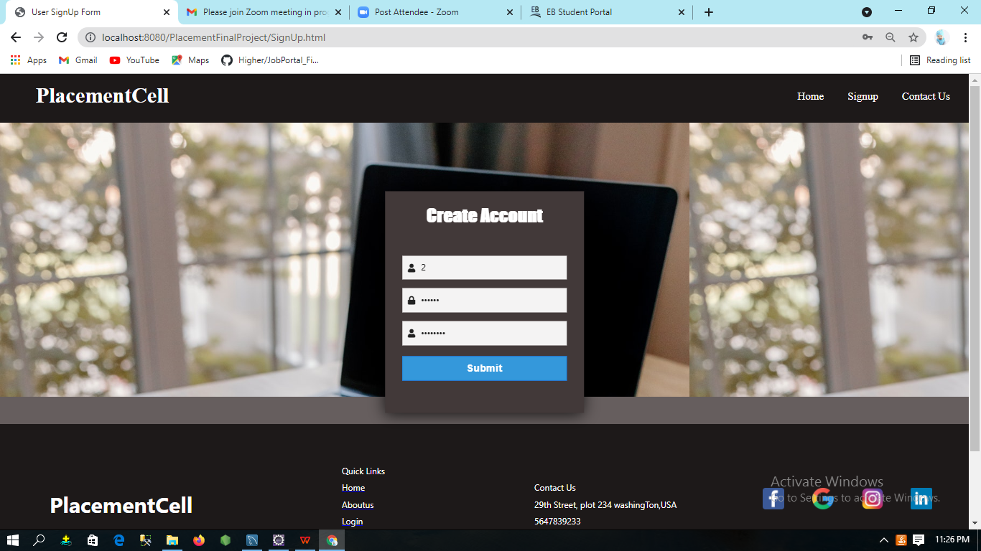

**Password Updation Page:**

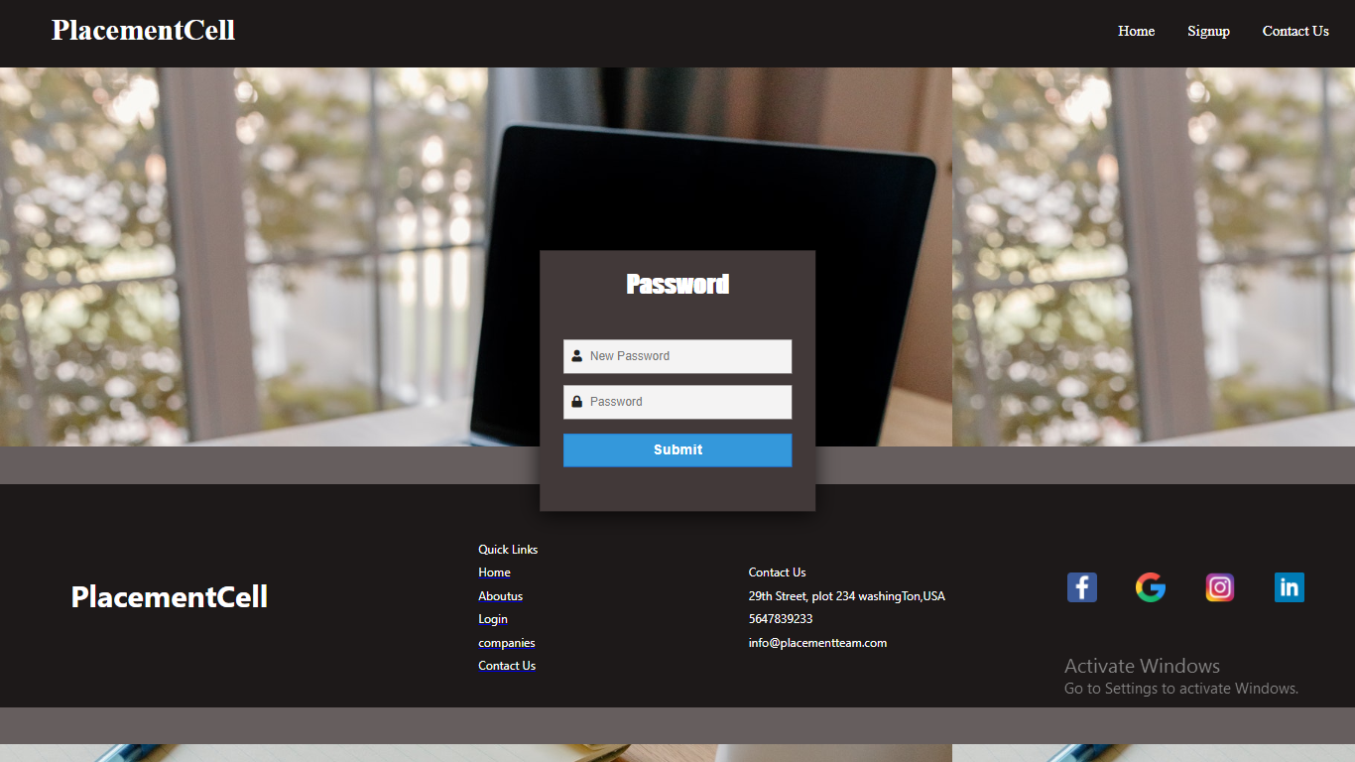

**Password Updation Page:**

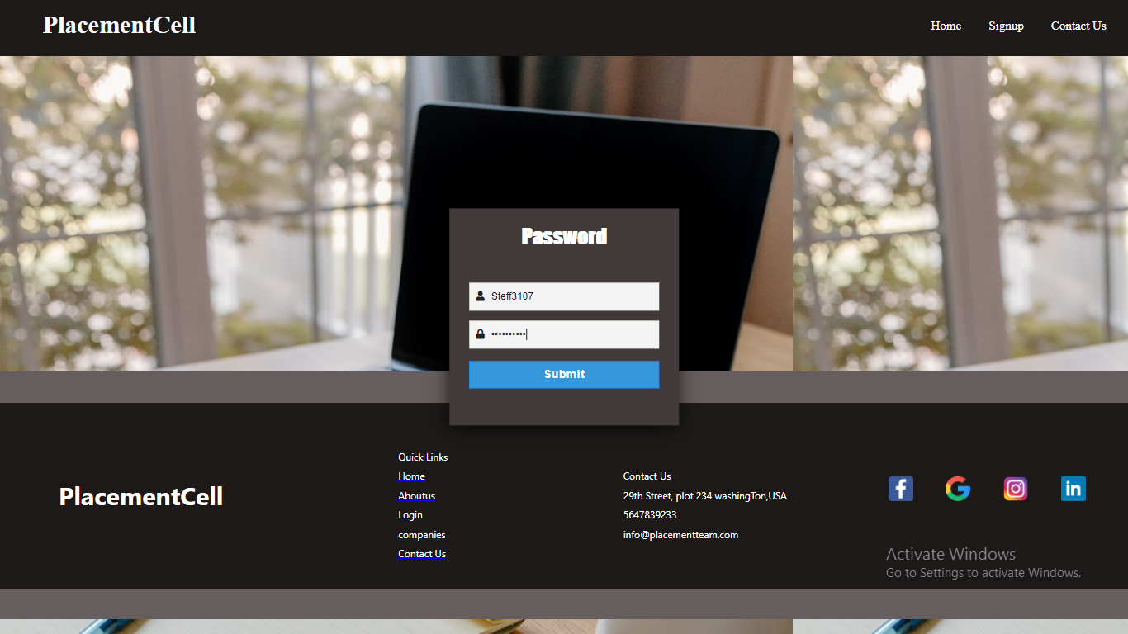

**User Dashboard Page:**

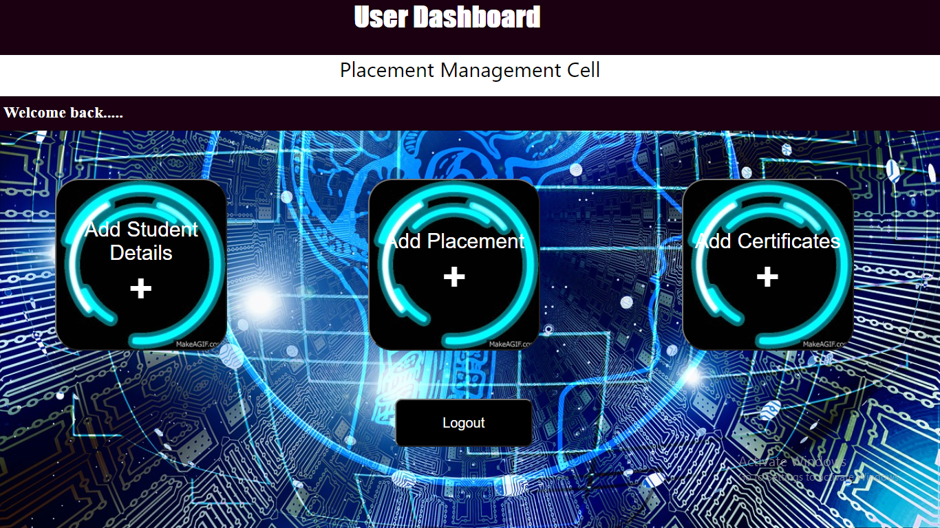

**Companies Page:**

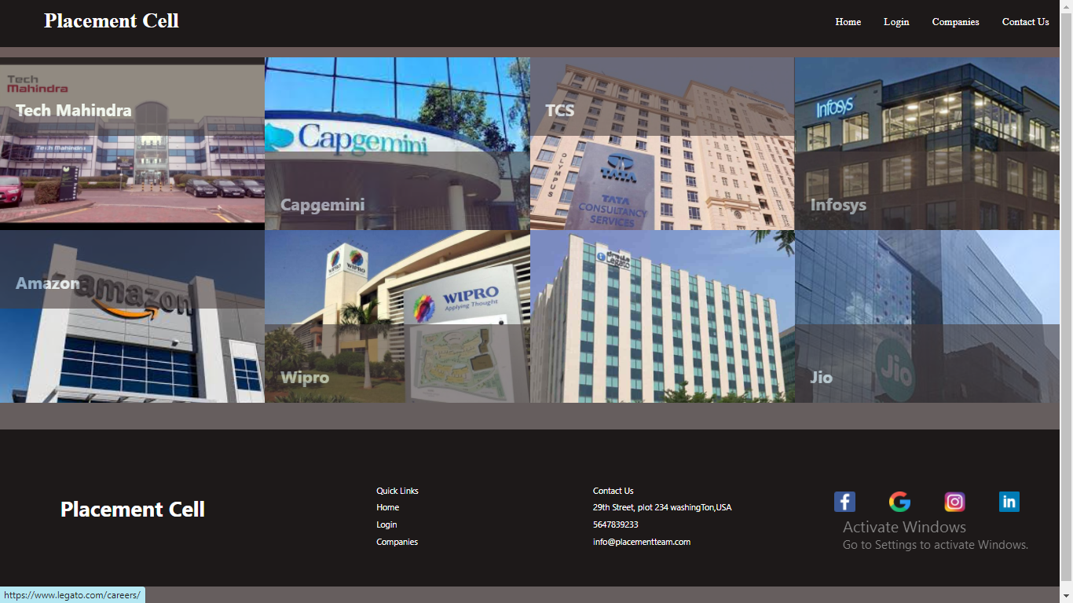

**Companies Page leads to respective Links:**

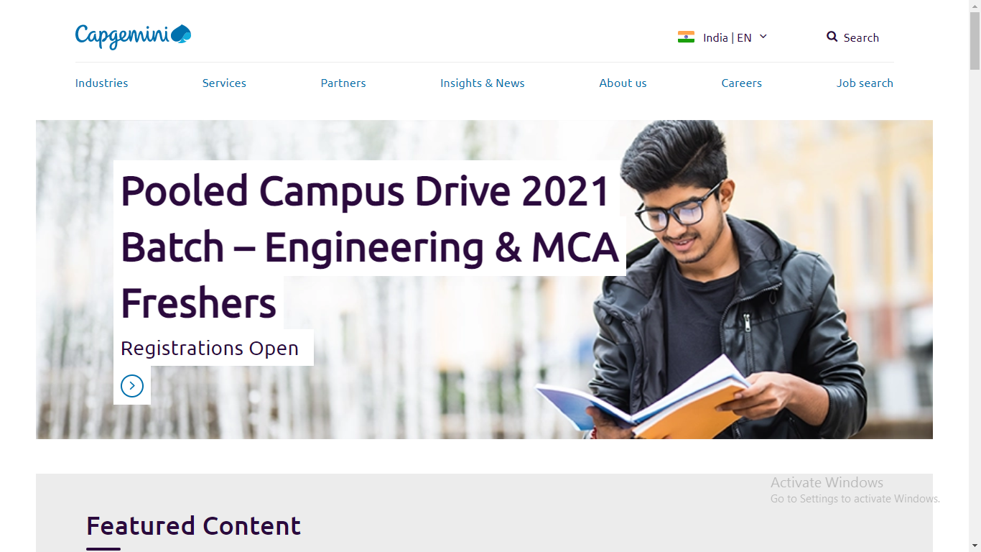

**About Us:**

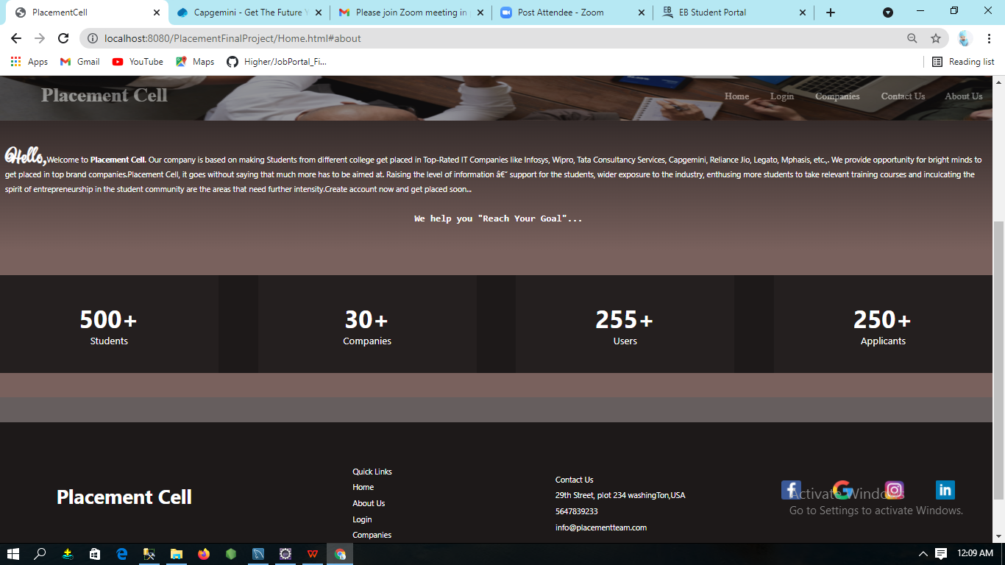

**Contact Us Page:**

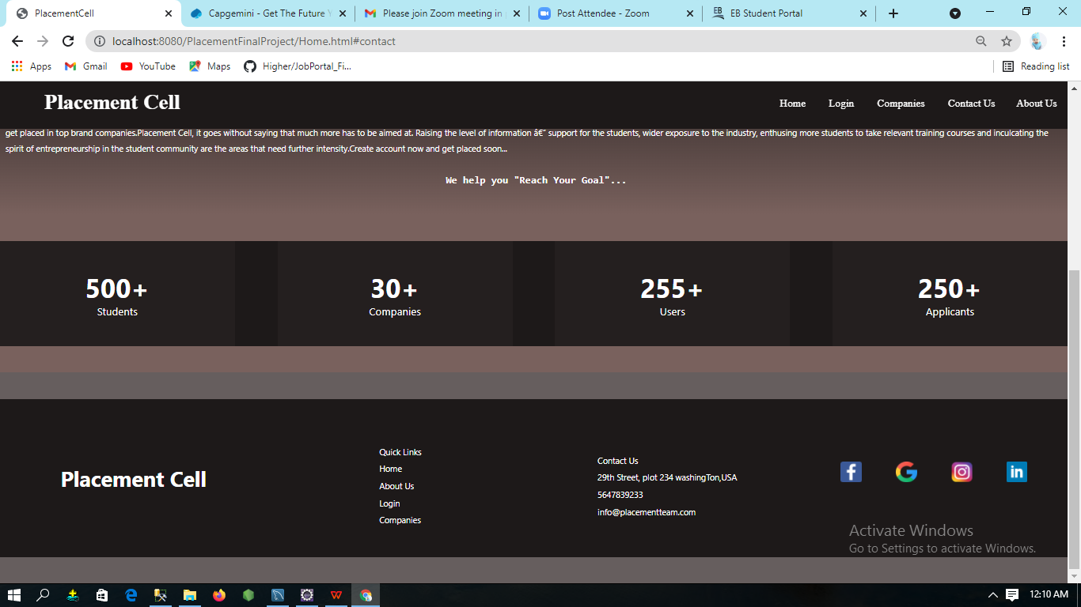

**DataAdded inDatabaseSuccessFully:**

1. **Admin Table**

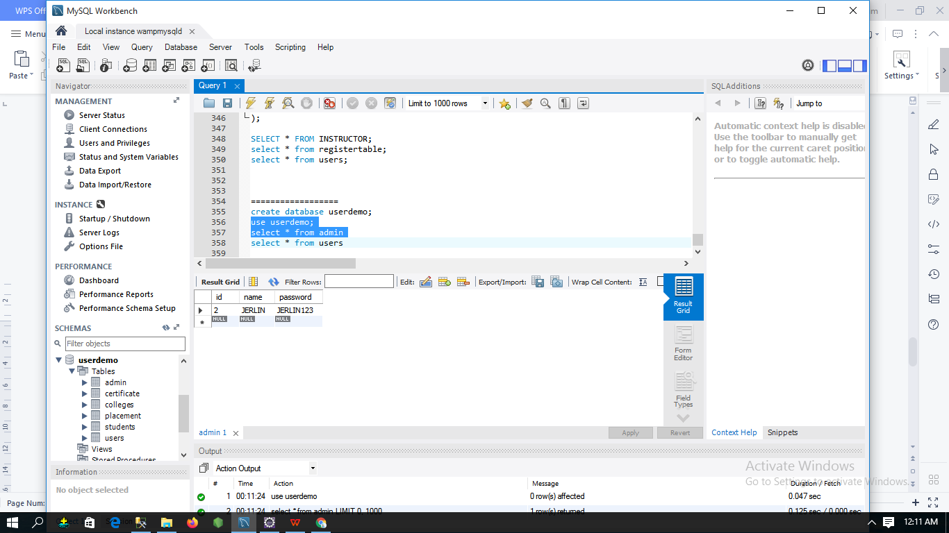

1. **Certificate Table**

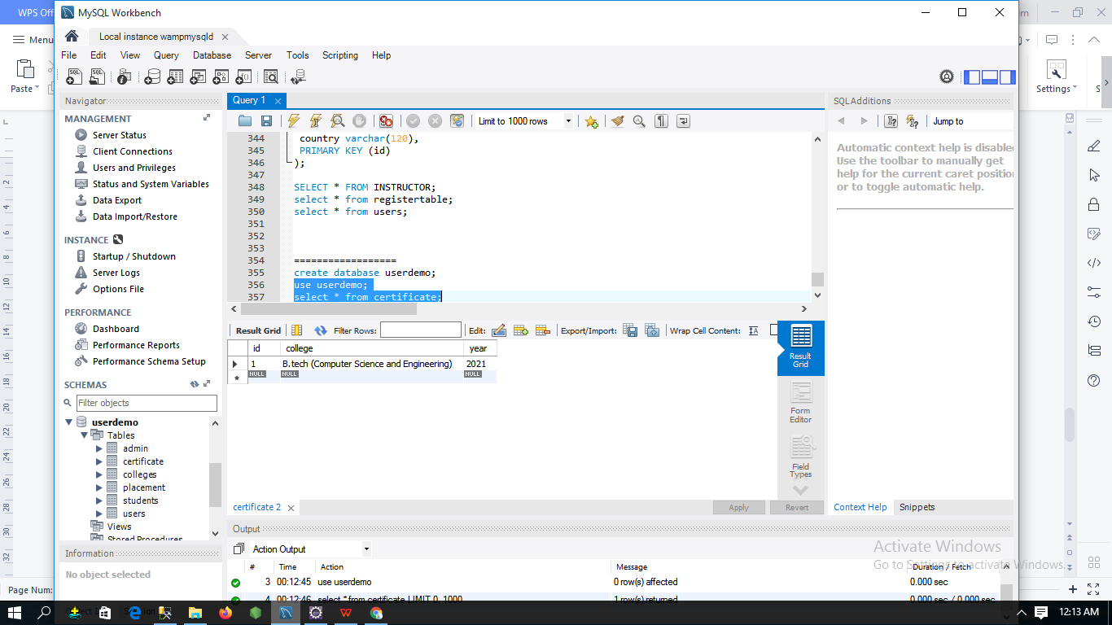

1. **College Table**

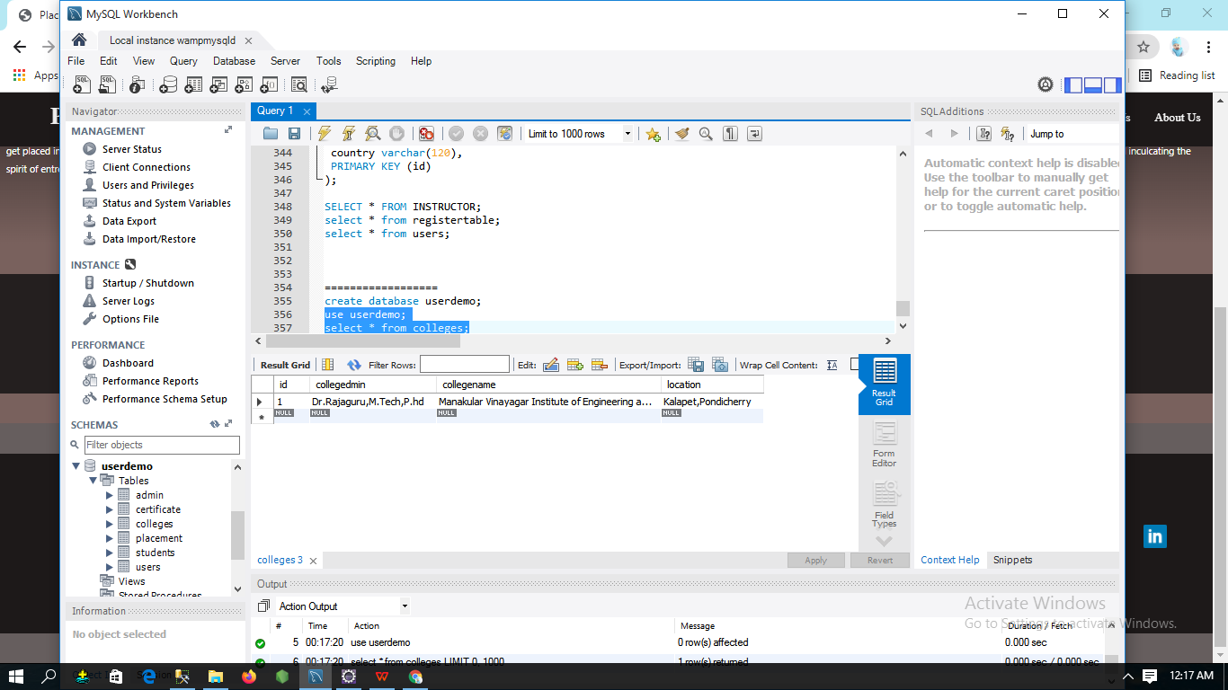

1. **Placement Table**

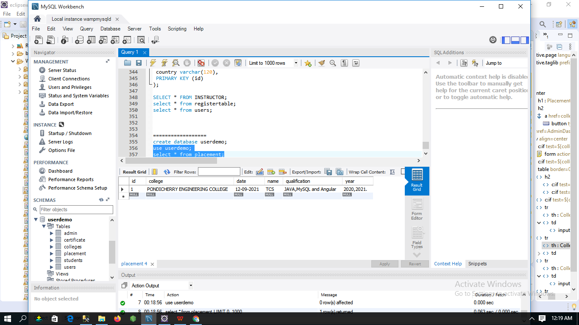

1. **Student Table**

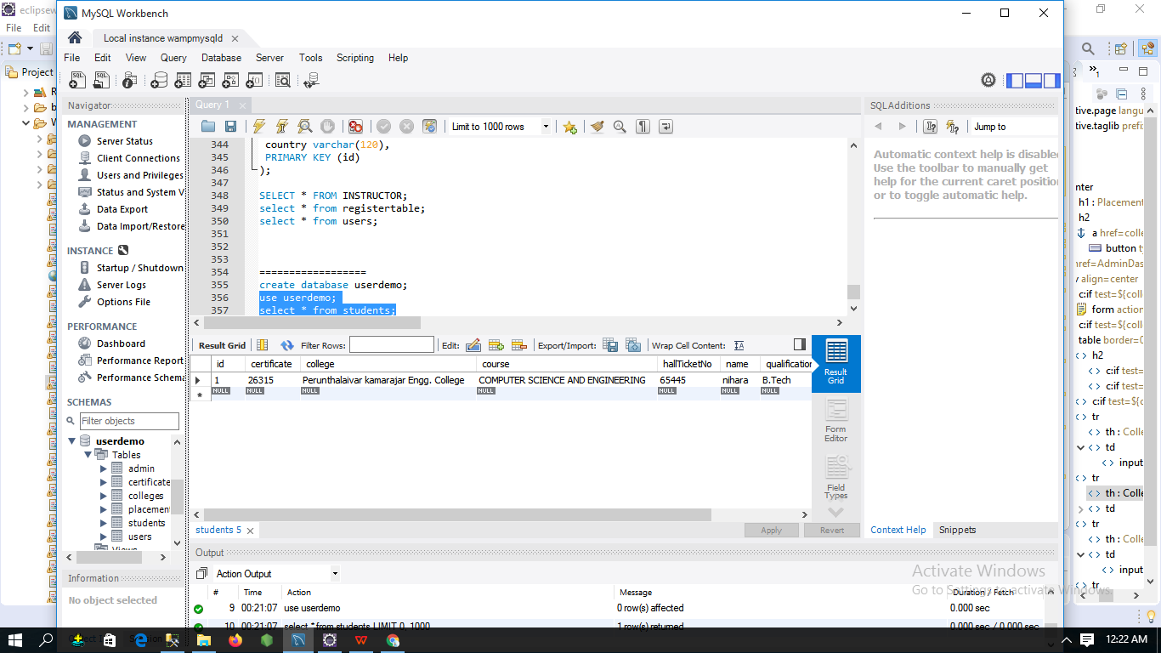

1. **User Table**

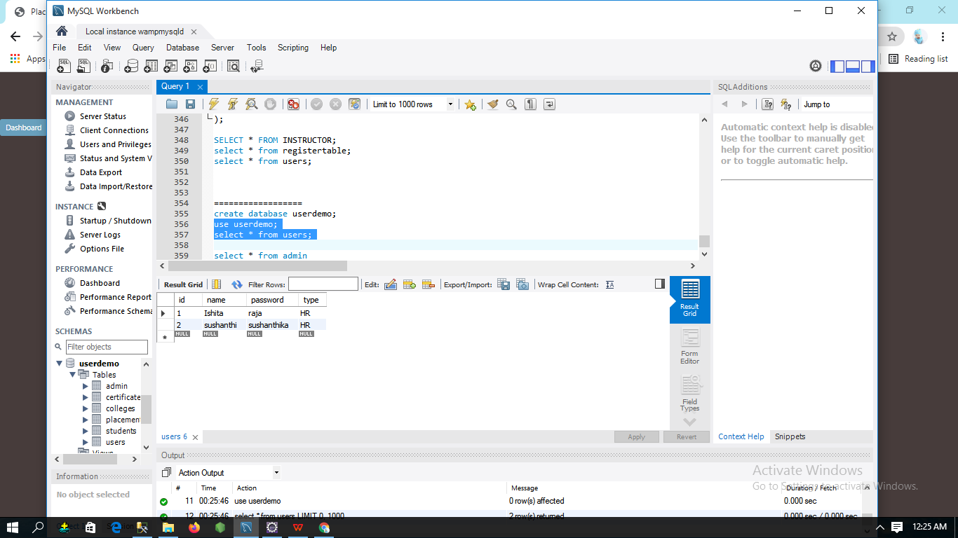

**Thank you**